**1) What are the two components that are most commonly found in a node struct of a linked list?**

(a) Some ability to hold data

(b) A link to the next node which is usually a pointer to the linked list struct.

**2) What role does the head pointer play?**

The head pointer is an external pointer that anchors the start of the linked list. We must always keep this pointer at the front so that we do not "lose" the list and end up with inaccessible nodes.

**3) What value do we give a pointer to indicate that it points to nothing?**

We use NULL (from C) or nullptr (from C++) to indicate a pointer that points to nothing. Both of these are defined as value 0, so a pointer with address 0 points to nothing.

**4) Explain why a linked list structure may be better than an array structure when we are inserting something in the middle of the list.**

If we want to insert something in the middle of a List, then we need to make room for it. If the implementation is an array, then inserting something in the middle involves copying (moving) all the items from the insert location through the end of the array down one spot so we can make room for the inserted item.

If the implementation of the List is a linked list, then an insert might be easier. We need a pointer to the link **before** the insert point. We create a new item and insert it into that location, linking the remaining items in the list after the new item. This does not involve "moving" any data. But we do need to traverse the list from the front to the insert point whereas in an array we can "jump" straight to the insert point.

If the data is small (like an int) then the copy/move process isn't too bad. If the data is big (like a giant array or structure) then the copy/move process can become time consuming.

**5) Explain why a linked list structure might use more memory than an array structure when implementing a List.**

Each node in a linked list has two parts: the data and the pointer. That adds an additional 8 bytes (for the pointer) to each item in the list. So a linked list requires more memory than an array of the same size because the array only needs to store the values and not the pointers.

**6) Explain why a linked list structure might use less memory than an array structure when implementing a List.**

However, an array is a fixed sized structure. If we have an array of 100 spots but only use 4 of them, then the array still needs enough memory allocated to hold 100 items. A linked list would only need to allocate the memory required for 4 spots. So if the array is mostly empty, then the linked list implementation might actually be using less memory space.

**7) Assume you have a linked list List structure using the following struct. Assume the list is already built and contains 10 items. Show how you can insert a link at the 4th position in the structure with the value 100.**

struct Node {

int value;

Node* next;

};

Node* head;

// code not shown to build the link lists with 10 items

// you sketch the steps below (or write code) to insert a new item with value 100 in the 4th spot in the List.

1) We must create a pointer and set it at the head. We call this the traversal pointer.

Node* traversal = head;

2) We then use this traversal pointer to traverse the linked list to the spot right before the insert location. In this case, the insert happens in the fourth spot, so we traverse to the third node in the list (two after the head).

for (int i = 0; i < 2; i++)

traversal = traversal -> next;

3) We use another pointer to create a new struct and add the value 100 in that new struct.

Node* toInsert = new Node;

toInsert -> value = 100;

4) We now set the next link of the new struct to point to the rest of the chain (after the insert point) by using the traversal pointer's next field.

toInsert -> next = traversal -> next;

5) Finally we set the traversal pointer's next field to point to the new item.

traversal -> next = toInsert;

Thus it is now fully inserted into the linked list.

Template Classes

* 16.1 in the book and the Counter.zip examples on Canvas (in the Classes module)
* Similar idea to template functions! Check arrays and user-defined types -> Polymorphism
* [You could stop at 5 or 6 stores or just 1](https://youtu.be/YCeQLeQiRP4?feature=shared)
* We want to define a blueprint for making a class definition on demand that works for different types (substituted in for T)
* At start of class declaration and each method definition:
  + template <typename T>
  + Then we can generate class definitions on-demand when we create objects:
    - Counter<int> c1;
    - Counter<char> c2('A');
* Things to keep in mind:
  + We can't compile separately anymore – we need to keep .h and .cpp files together
  + How will we manage the different types? Is there behavior we need to think about? What types does this work for?
    - Think about the operations, operators we are using and compatibility

Dynamically-Resized Arrays

* Say we have an array with capacity 80 representing a List with 80 items in it
* To append an 81st item, we need to **reallocate**
  + Double the capacity
  + Create a new array with the capacity to hold 160 items
  + Copy the items from the old array to the new array
  + Put the new item in the new array
  + Free up space for the old array
* What if we never need to hold any more items than this?
  + 79 spots reserved in memory that we aren't actually using
* What if we didn't need to reallocate?

Linked Lists

The first rectangle which is divided into 2 parts is placed in the top right corner. It holds the value 58 and a slash. 3 rectangles are placed in a row below the first rectangle. The first rectangle in row 2 is labeled as head. The second and third rectangle in row 2 is divided into 2 parts. The values of second and third rectangle are as follows: 4, blank, and 46, blank. Another 2 rectangles which are divided into 2 parts are placed slightly in bottom center. The values of 2 rectangles are as follows: 16, blank, and 39, blank. An arrow from head points to value 4. The blank part with 4 points to 16. The blank part with 16 points to 39. The blank part with 39 points to 46. The blank part with 46 points to 58.  


struct Node

{

T item;

Node* next;

};

* To navigate through a linked list:
  + I need an external pointer to the head (first element in the list) -- this pointer is not inside any node
  + I create another pointer Node* ptr = head;
  + I follow the trail of next pointers:
    - ptr = ptr -> next;
  + I stop when I reach the nullptr

Inserting into a Linked List

The first rectangle which is divided into 2 parts is placed in the top right corner. It holds the value 58 and a slash. 3 rectangles are placed in a row below the first rectangle. The first rectangle in row 2 is labeled as head. The second and third rectangle in row 2 is divided into 2 parts. The values of second and third rectangle are as follows: 4, blank, and 46, blank. Another 2 rectangles which are divided into 2 parts are placed slightly in bottom center. The values of 2 rectangles are as follows: 16, blank, and 39, blank. An arrow from head points to value 4. The blank part with 4 points to 16. The blank part with 16 points to 39. The blank part with 39 points to 46. The blank part with 46 points to 58.  


struct Node

{

T item;

Node* next;

};

* To insert an element at the end of the list:
  + Let's appending 5 to the list above
  + Navigate to the last node in the list (traverse the list)
  + Create a new Node
    - Allocate memory for it & create a pointer to it
    - Set item to 5
    - Set next to nullptr
  + Re-assign the next member of the previously last element to point to the new Node
* To insert an element at the beginning of the list:
  + To add another 4 before the first 4 in the list above
  + We have a pointer to the first node: head – we are already where we need to be
  + Create a new Node
    - Allocate memory for it & create a pointer to it
    - Set item to 4
    - Set next to head
  + Re-assign head to point to the newly created   
    Node
* To insert an element in the middle of the list:
  + Let's add 21 at index 2
  + Partially traverse the list
    - We want to stop 1 index before the index where we are adding our new item
    - Create a new Node
      * Allocate memory for it & create a pointer to it
      * Set item to 21
    - Set our newly created node's next member to point to the Node previously at index 2 (access that through the next member of the element at index 1)
    - Then update the next member of the Node at index 1 to point to our newly created Node

Removing from a Linked List

The first rectangle which is divided into 2 parts is placed in the top right corner. It holds the value 58 and a slash. 3 rectangles are placed in a row below the first rectangle. The first rectangle in row 2 is labeled as head. The second and third rectangle in row 2 is divided into 2 parts. The values of second and third rectangle are as follows: 4, blank, and 46, blank. Another 2 rectangles which are divided into 2 parts are placed slightly in bottom center. The values of 2 rectangles are as follows: 16, blank, and 39, blank. An arrow from head points to value 4. The blank part with 4 points to 16. The blank part with 16 points to 39. The blank part with 39 points to 46. The blank part with 46 points to 58.  


struct Node

{

T item;

Node* next;

};

* To remove an element in the middle of the list:
  + Let's remove 39 (at index 2)
  + Partially traverse the list
    - We want to stop 1 index before the index where we are removing an item
    - We want to create a pointer that points to the Node we are removing
    - Make the Node at index 1 (the preceding index) point to the Node the node to be removed points to in its next field
    - Delete the node (deallocate/free up its memory)

Linked Lists vs. Arrays

* Space
  + Arrays:
    - We might have memory allocated for spots in our array that we aren't actually using
  + Linked Lists:
    - We create each node on-demand, only when it's needed and free that space back up when it's no longer needed
    - Pointers take up space in memory!
    - Each individual element of our list takes up more space in memory than they would in an array (space for the data + the pointer)
  + What determines which takes up more space?
    - How much space does a pointer take up in memory?
      * Machine-dependent
      * 32 vs 64 bit memory
      * We might not know specifically what system
    - How much space does an element of type T take up in memory?
      * Something like a char takes up very little memory relative to the cost of adding a pointer
      * If our T is a student record/object/some larger type composed of several smaller types, then adding a pointer might be relatively cheap
* Time complexity/efficiency
  + How much more time does it take to do things when the number of things in our list (n) increases?
  + Accessing elements is fast in an array, slower in a linked list
    - For an array, we calculate the address for an item at a specific position using the formula we learned a long time ago – we do this once, no matter what that index/position is
      * Constant-time – does not change based on the number of things in the list
    - For a linked list, we have to navigate to the position/index from the start of the list
      * This time depends on how far we need to go from the first element
      * On average, we probably need to go through about n/2
      * Linear-time: gets slower when we have more items in our list
  + Inserting items in our list:
    - Inserting items into an array:
      * Start by accessing
      * Shift a bunch of things over
      * Linear time, depends on how many things we need to shift over (position we are inserting at)
      * Inserting at the beginning: we have to shift everything over, which is slow
      * Inserting at the end: usually faster – usually don't have to shift anything
        + *** unless we have to reallocate
    - Inserting items into a linked list:
      * Also need to access – already linear time
      * Once we get there, it's constant time (make a new node, set item value and 2 pointer assignments)
      * Inserting at the beginning: faster because we don't need to navigate through any nodes in the list – just update head
      * Inserting at the end: slower, because we have to navigate all the way through the list

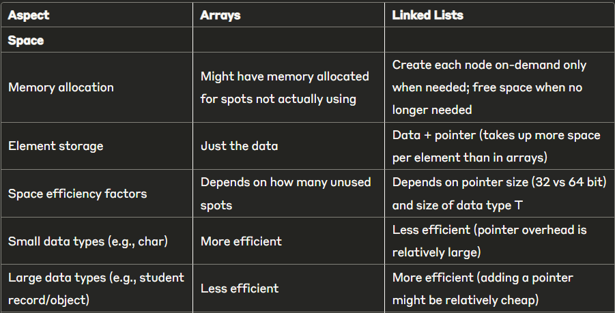

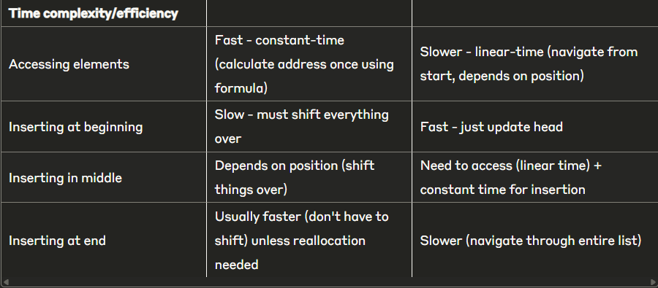

1. Assume you have your complete List class from Project 10 using a dynamically allocated array. The class declaration (with one extra method declaration) is shown below.

#define DEFAULT_LIST_SIZE 10

template <typename T>

class List

{

public:

List ( );

List ( const List<T> &l );

~List ( );

List<T> operator= ( const List<T> &l );

void append ( T data );

void insert ( T data, int position );

int length ( ) const;

T & operator[] ( int position );

void remove ( int position );

bool isEmpty ( ) const;

List<T> operator+ ( const List<T> &l ) const;

List<T> operator* ( const List<T> &l ) const;

void clear ( );

friend ostream & operator<< (ostream &os, const List<T> &list);

private:

// the maximum capacity of the array storing the list

int capacity;

// the current number of items in the list

int size;

// the dynamically allocated array storing the list

T *list;

// make the array twice as big to hold more data

void reallocate ( );

};

You will add a new interleave operator by overloading *. This operator will interleave the two lists into a new third list. For example:

if these two lists have these values currently:

list1 = [1, 2, 3]

list2 = [10, 20, 30, 40, 50]

then a call like this:

list3 = list1 * list2;

will fill in list3 with these values: list3 = [1, 10, 2, 20, 3, 30, 40, 50]

The interleave operation alternately takes items from list1 and list2 as they are added to list3. This alternate selection continues while there are still elements left in both lists. When one list is exhausted, then we simply add all the remaining elements from the other list (as shown in the example). This is very similar to operator+ except that the values are interleaved instead of operator+ which places all values of list1 first and then all values from list2 second.

You are permitted to call any of the other List public methods in the List ADT in your new function.

Write the code for operator* below (on the following page).

template <class T>

List<T> List<T>::operator* ( const List<T> &mylist ) const { }

2. Is it more efficient to add new items at the beginning or end of an array? Is it more efficient to add new items at the beginning or end of a linked list?

3. Consider the List class using a linked list that you are writing for Project 11. Part of the class declaration is shown below. On the next page, you are to write a new-method called isSorted () which returns true if the list is in sorted order from smallest to biggest and false otherwise. You can assume the template type T has operators for > and for < so that you can compare two items appropriately. An empty list or a list with one item is considered sorted.

template <class T>

class List

{

private:

struct Node

{

T item;

Node * next;

};

Node *head; // head pointer to linked list

public:

... more code not shown

}

Here is the method you are to complete:

template <class T>

bool List<T>::isSorted() const { }